If dq is the heat supplied to a gas during a heating process and due to this internal energy of a gas increases by du and gas does a work dW against surrounding then according to first law of thermodynamics, we have

dQ = dU + dW

This equation is called differential form of first law of thermodynamics. If a gas is heated from an initial state to a final state by a process and if total heat supplied in the heating is Delta*Q total work done by the gas is Delta*W and total change in internal energy of the gas is Delta*U then we have

Delta*Q = Delta*W + Delta*U

U = Q - W

Specific Heat Capacities of Gases

Specific heat of a gas can be defined as the amount of heat required for a unit mass of a gas to raise its temperature by one degree. If instead of unit mass we take one mole of gas then it is termed as molar specific heat or molar heat capacity of the gas. It is denoted by C and if n moles of a gas is heated on dQ supply of heat, and if gas temperature increases by dT, then we have

dQ = nCdT

If temperature of gas charges from T_{1} to T_{2}

Then total heat supplied is Q = int dQ

= int_(T_{1})^( T_{2}) nC dT

= nC(T_{2} - T_{1})

Change in Internal Energy of a Gas on Heating

when heat is supplied to a system, it may be possible that gas expands. If it expands, we say gas does work against surrounding. It means some energy out of supplied heat goes to the surrounding in this work done. Similarly it may be possible that a part of supplied - heat increases the kinetic energy of gas molecules. This means the temperature of gas increases. If temperature of gas increases - by a small amount dT, we can say that the total internal energy = of gas is also increased by a small amount, say du, which can be given as

dU = f/2 nRdT

Similarly if in a case gas temperature decreases, then equation gives the decrement in internal energy and we write this equation with a negative sign on either side of equality.

If total change in temperature of gas is from T_{1} to T_{2} then total change in its internal energy from initial to final state is

DeltaU = int dU = int_(T_{1})^( T_{2}) f/2 nR dT

DeltaU = f/2 nR(T_{2} - T_{1})

Properties of an Indicator Diagram

Figure shows a general indicator diagram for a thermodynamic process for heating of a gas from state-1 to state-2. The path of this process is shown in figure from initial to final state. Some standard characteristic of a P-V curve plotted for a thermodynamic process are

(i) Each point on an indicator diagram represents a unique state of a gas. In a P-V diagram, each points gives a specific value of pressure and volume of a gas and if number of moles are known, we can get its temperature using gas law. Hence a PV curve is the locus of the states of a gas during a thermodynamic process between initial and final states.

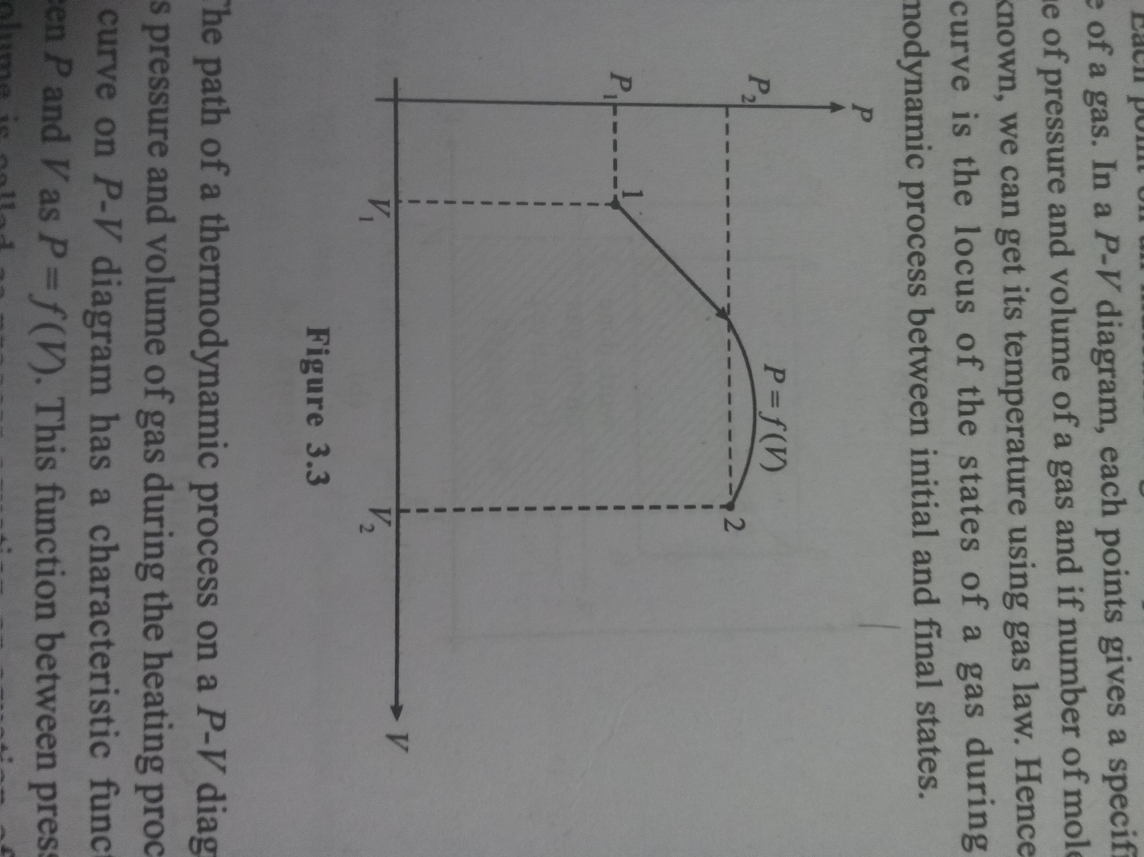

(ii) The path of a thermodynamic process on a P-V diagram relates pressure and volume of gas during the heating process. Each curve on P-V diagram has a characteristic function between P and Vas P = f(V) This function between pressure and volume is called as process equation or equation of the thermodynamic process between state-1 and state-2.

(iii) In a thermodynamic process, the work done by the gas, we've already discussed, is given as

W = int_(V_{1})^( V_{2}) P dV

If the process equation is known we can solve the integral in above equation as

W = int_(V_{1})^( V_{2}) f(V) dV

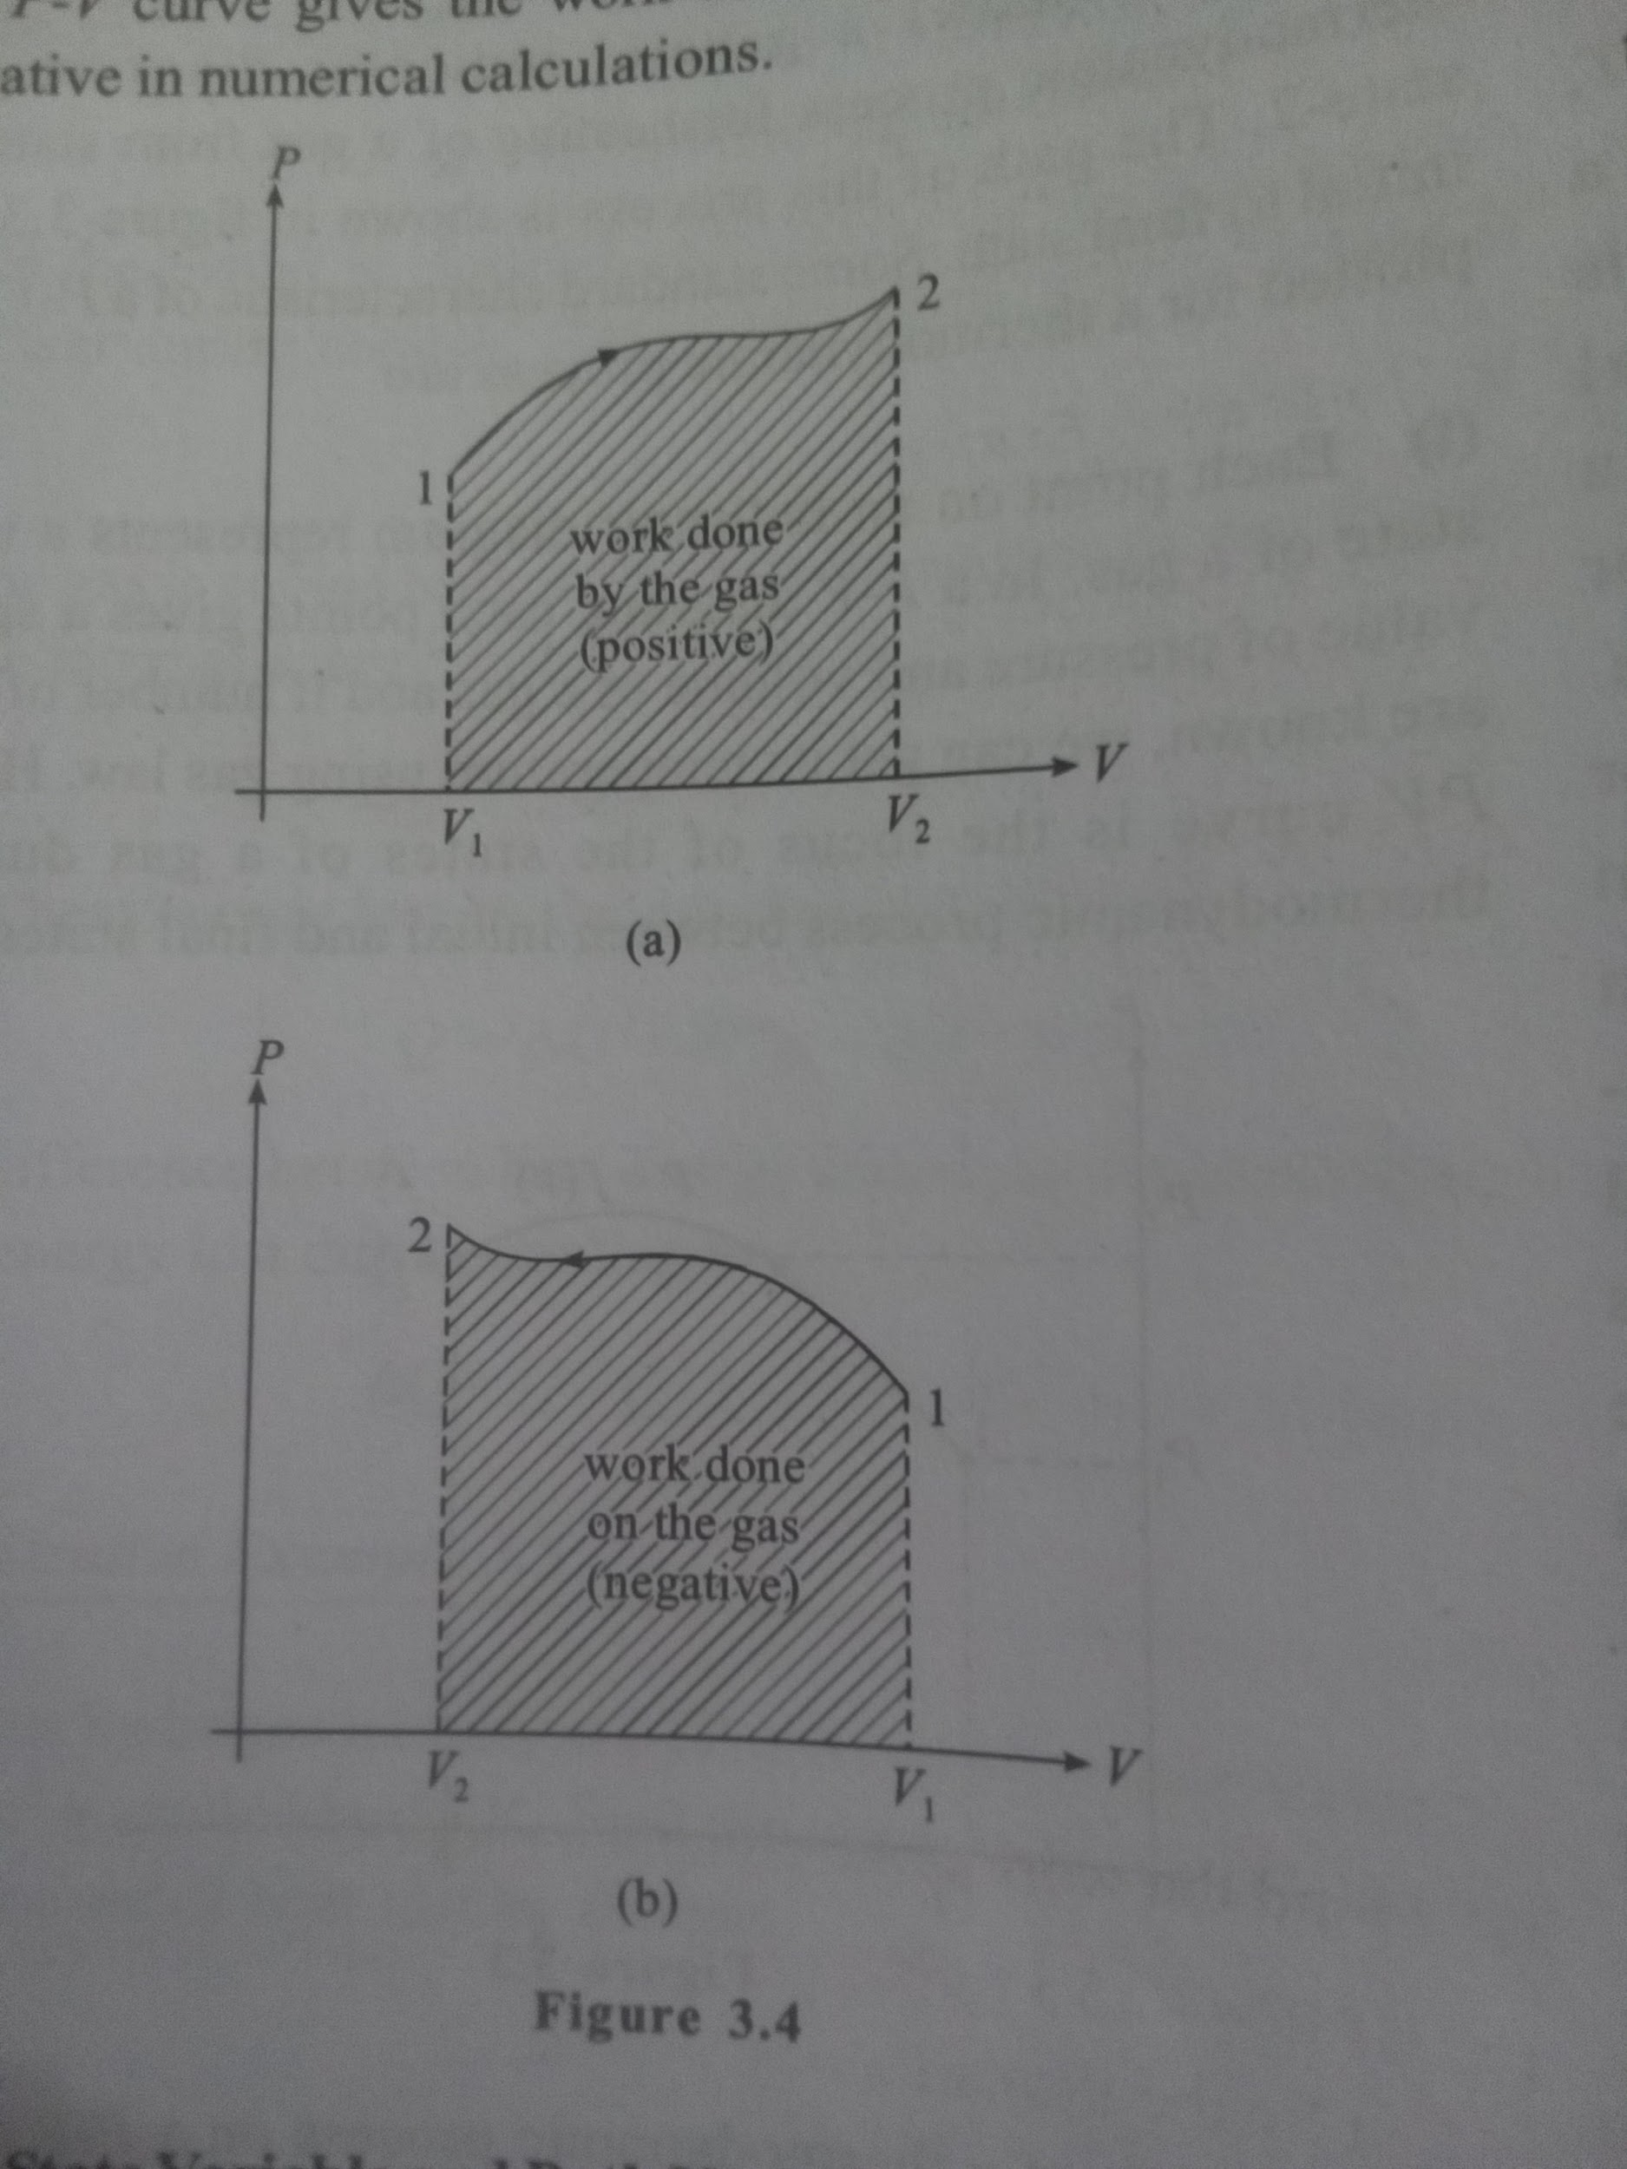

Cyclic process

Delta U =0

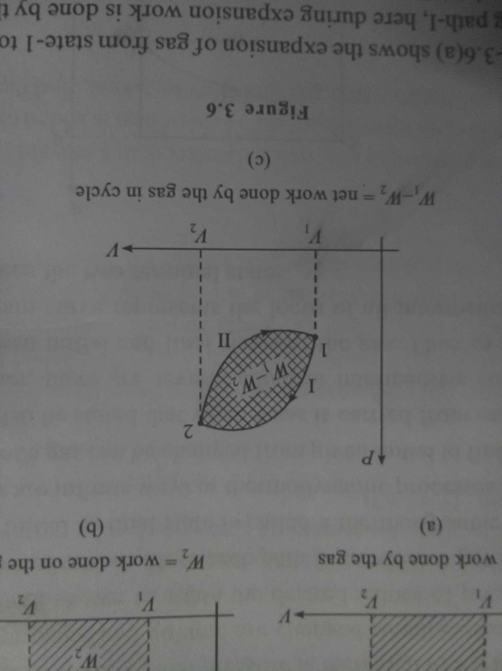

As discussed initially that in a cyclic process net change in

internal energy of gas is zero thus the total work done is equal

to the total amount of heat supplied to the gas. In fact during

first part of the cycle i.e. during expansion of gas, heat is

supplied and work is done by the gas, say heat supplied to the

gas is Q_{1} In second part of the cycle i.e. during compression

of gas, work is done on the gas and some heat is rejected by

the gas to its surrounding say this amount is Q_{2} As total work

is done by the gas thus we generally have Q_{1} > Q_{2} so total heat

supplied to the gas can be written as

DeltaQ = Q_{1} - Q_{2}

This must be equal to the total work done by gas as Delta*U = 0 in the complete cycle. Thus

DeltaQ = Q_{1} - Q_{2} = Delta*W = W_{1} - W_{2}

Cyclic processes in which PV curve is clockwise, net work is done by the gas, such cycles are called heat engine cycles. And those processes in which PV curve is anticlockwise, net work is done on the gas and heat is rejected by the gas to the surrounding, such cycles are called refrigeration cycles.

Molar Heat Capacity at Constant Volume (Cv)

This is the amount of heat required for one mole of a gas to raise its temperature by one degree at constant volume. This is denoted by Cv. If a gas is heated at constant volume, we can simply state that no work is done by the gas or on the gas during heating. Thus if we apply first law of thermodynamics to such type of a heating process, we get

dQ = dU + dW

dQ = dU or [As v constant, dW = 0]

nC_{V} dT = f/2 * nRdT [As dQ = nC_{V} dT ]

C_{V} = f/2 * R

Above relation states that when volume of a gas is constant during heating, no work is done. This implies that the total amount of heat supplied to the gas is used in increasing internal energy of gas, that is to raise the temperature.

|  |  |  |
| --- | --- | --- |
| Type of Gas | No. of degrees of freedom(f) | Molar heat capacity at constant volume(c_{V} |
| Monoatomic gas | 3 | 3/2 R |
| Diatomic gas at lower temperature | 5 | 5/2 * R |
| Diatomic gas at higher temperature | 7 | 7/2 * R |
| Polyatomic gas linear molecule | 5 + x (variable.) | ((5 + x)/2) * R |
| Polyatomic gas non linear molecule | 6 + x (vib.) | (6 + x)/2 * R |

Molar Heat Capacity at Constant Pressure (C_{p})

It is the amount of heat required for one mole of a gas to raise its temperature by one degree at constant pressure. It is denoted by C_{P}

When a gas is heated at constant pressure, with rise in temperature volume of gas must increase by gas law as

PV = nRT

Differentiating gas law gives

PdV+VdP=nRdT

is called "differential form of gas law". If during heating pressure of gas is a constant, second term on left hand side of equality will be zero thus we have

P * dV = nRdT [As dP = 0 for constant pressure]

Which is also the elemental work done by the gas. This is a process when gas pressure does not change during heating, if volume of gas changes from V_{1} to V_{2} and temperature changes from T_{1} to T_{2} the total work done is given as

W = int_ V_{1} ^ V_{2} P dV = int_ T_{1} ^ T_{2} nR dT

W = P(V_{2} - V_{1}) = nR(T_{2} - T_{1})

According to first law of thermodynamics, if do is the heat supplied to a gaseous system at constant pressure, du is the increase in internal energy and if dw is the work done by the gas, then we have

dQ = dU + dW

If C_{P} is the molar heat capacity for this gas then we have

n*C_{P} * dT = f/2 * nR * dT + PdV [As dQ = n*C_{P} * dT ]

nC_{p} dT = f/2 nR dT + nRdT [as PdV=nRT for constant pressure]

C_{p} = f/2 R + R = ((f + 2)/2) * R

C_{P} = C_{V} + R

Mayor's relation

|  |  |  |
| --- | --- | --- |
| Type of Gas | No. of degrees of freedom(f) | Molar heat capacity at constant pressure C_{P} |
| Monoatomic gas | 3 | 5/2 R |
| Diatomic gas at lower temperature | 5 | 7/2 * R |
| Diatomic gas at higher temperature | 7 | 9/2 * R |
| Polyatomic gas linear molecule | 5 + x (variable.) | ((7 + x)/2) * R |
| Polyatomic gas non linear molecule | 6 + x (vib.) | (8 + x)/2 * R |

Ratio of Heat Capacities of a Gas

C_{V} = f/2 * R

and

C_{P} = (f + 2)/2 * R

The values of C_{P} and C_{V} are the characteristic properties of a gas. One more characteristic property is widely used in analyzing the behaviour of gas. This is ratio of the two specific heats of a gas and is termed as adiabatic exponent of a gas. It is denoted by y as

gamma = C_{P}/C_{V} = (f + 2)/f

we can represent number of degrees of freedom in terms of y as

f = (2/(gamma - 1))

we can represent C_{P} and C_{V} in terms of gamma as

C_{v} = f/2 * R = R/(gamma - 1)

and C_{P} = gamma*C_{V} = (gamma*R)/(gamma - 1)

Ratio of Specific Heats for a Mixture of Gases

if N gases of n_{1} n_{2} …n_{N} are mixed at a common temperature T, the internal energy of the mixture remains constant. If these N gases have values of C_{V} as C_{V1} ,C_{V 2} ……… C_{V_{N}} then we have

n_{1} C_{V1}T+ ……. n_{N} C_{V_{N}} T

= ( n_{1} + n_{2} + ……. n_{N} )C_{V_{eq}} T

C_{V_{eq}} = (n_{1} C_{V1} + n_{2}C_{V2} + …….. +n_{N} C_{V_{N}})/( n_{1} +n_{2} + ……. n_{N})

Where C_{V_{eq}} is the equivalent molar specific heat for the mixture of gases constant volume similarly C_{P_{eq}} for the mixture of gases can be given as

C_{P_{eq}} = (n_{1} C_{p1} +n_{2} C_{p2} + …….. +n_{N} C_{p_{eq}})/( n_{1} +n_{2} + …… n_{N})

If gamma_{1},gamma_{2} …….. gamma_{N} are the ratio of specific heats for these independent gas then from equation-(3.25) we have

(n_{1}RT)/(gamma_{1} - 1) + (n_{2}RT)/(gamma_{2} - 1) +....... (n_{N}RT)/( gamma_{N} -1)

=( n_{1} + n_{2} + ….. n_{N} )( R/( gamma_{eq} -1 )T [As C_{v} = R/(gamma - 1) ]

Here gamma_{eq} is the equivalent adiabatic exponent for the mixture of gases and given by the equation

n_{1}/(gamma_{1} - 1) + n_{2}/(gamma_{2} - 1) +...+ n_{N}/( gamma_{N} -1) = (n_{1} +n_{2} + ….. +n_{N})/(gamma_{eq}-1)

Different Type of Thermodynamic Processes

We've already discussed that a thermodynamic process is a way of heating a gas or doing work on it by which state of a gas can be changed from one to another by a specific path. Each thermodynamic process can be represented by a specific P = f (V) curve on a P-V indicator diagram. In each thermodynamic process, there are three variable related. Heat supplied to a gas, change in its internal energy and work done by a gas. According to first law of thermodynamics a part of supplied heat is used as rise in internal energy of gas and rest is used to do work against surrounding. As we change the process of heating, the fraction of heat supplied which is used * to increase the internal energy of gas and the fraction of heat supplied consumed in doing work will change. These three variables heat supplied Q, change in internal energy of a gas AU and work done Ware called thermodynamic variables for a process.

There are some standard thermodynamic processes, commonly used in practice, these are

(1) Isochoric or Isometric Process

(2) Isobaric Process

(3) Isothermal Process

(4) Adiabatic Process

Isochoric or Isometric Process

In this process volume of gas remains constant during heating or state changing process on a gas. Thus during the heating process, we have dV = 0 [During the process V = constant] Delta*V = 0 [As V_{1} = V_{2} ] and As no change in volume is taking place, work done by the gas in the process is zero. Some time in few processes Delta*V = 0 but d V ne0 We can not treat these processes as isochoric because

in such processes initial and final volume of the gas are same but during the process, volume change takes place. We can differentiate these processes easily by looking carefully on their PV diagrams as shown in figure-3.29.

Figure-3.29(a) shows a PV diagram of an isochoric process in which, when a gas is carried from state-1 to state-2, its volume V remains constant during heating, only increase in pressure takes place as shown and the effective area below the PV-curve is also zero which shows no work is done during the process.

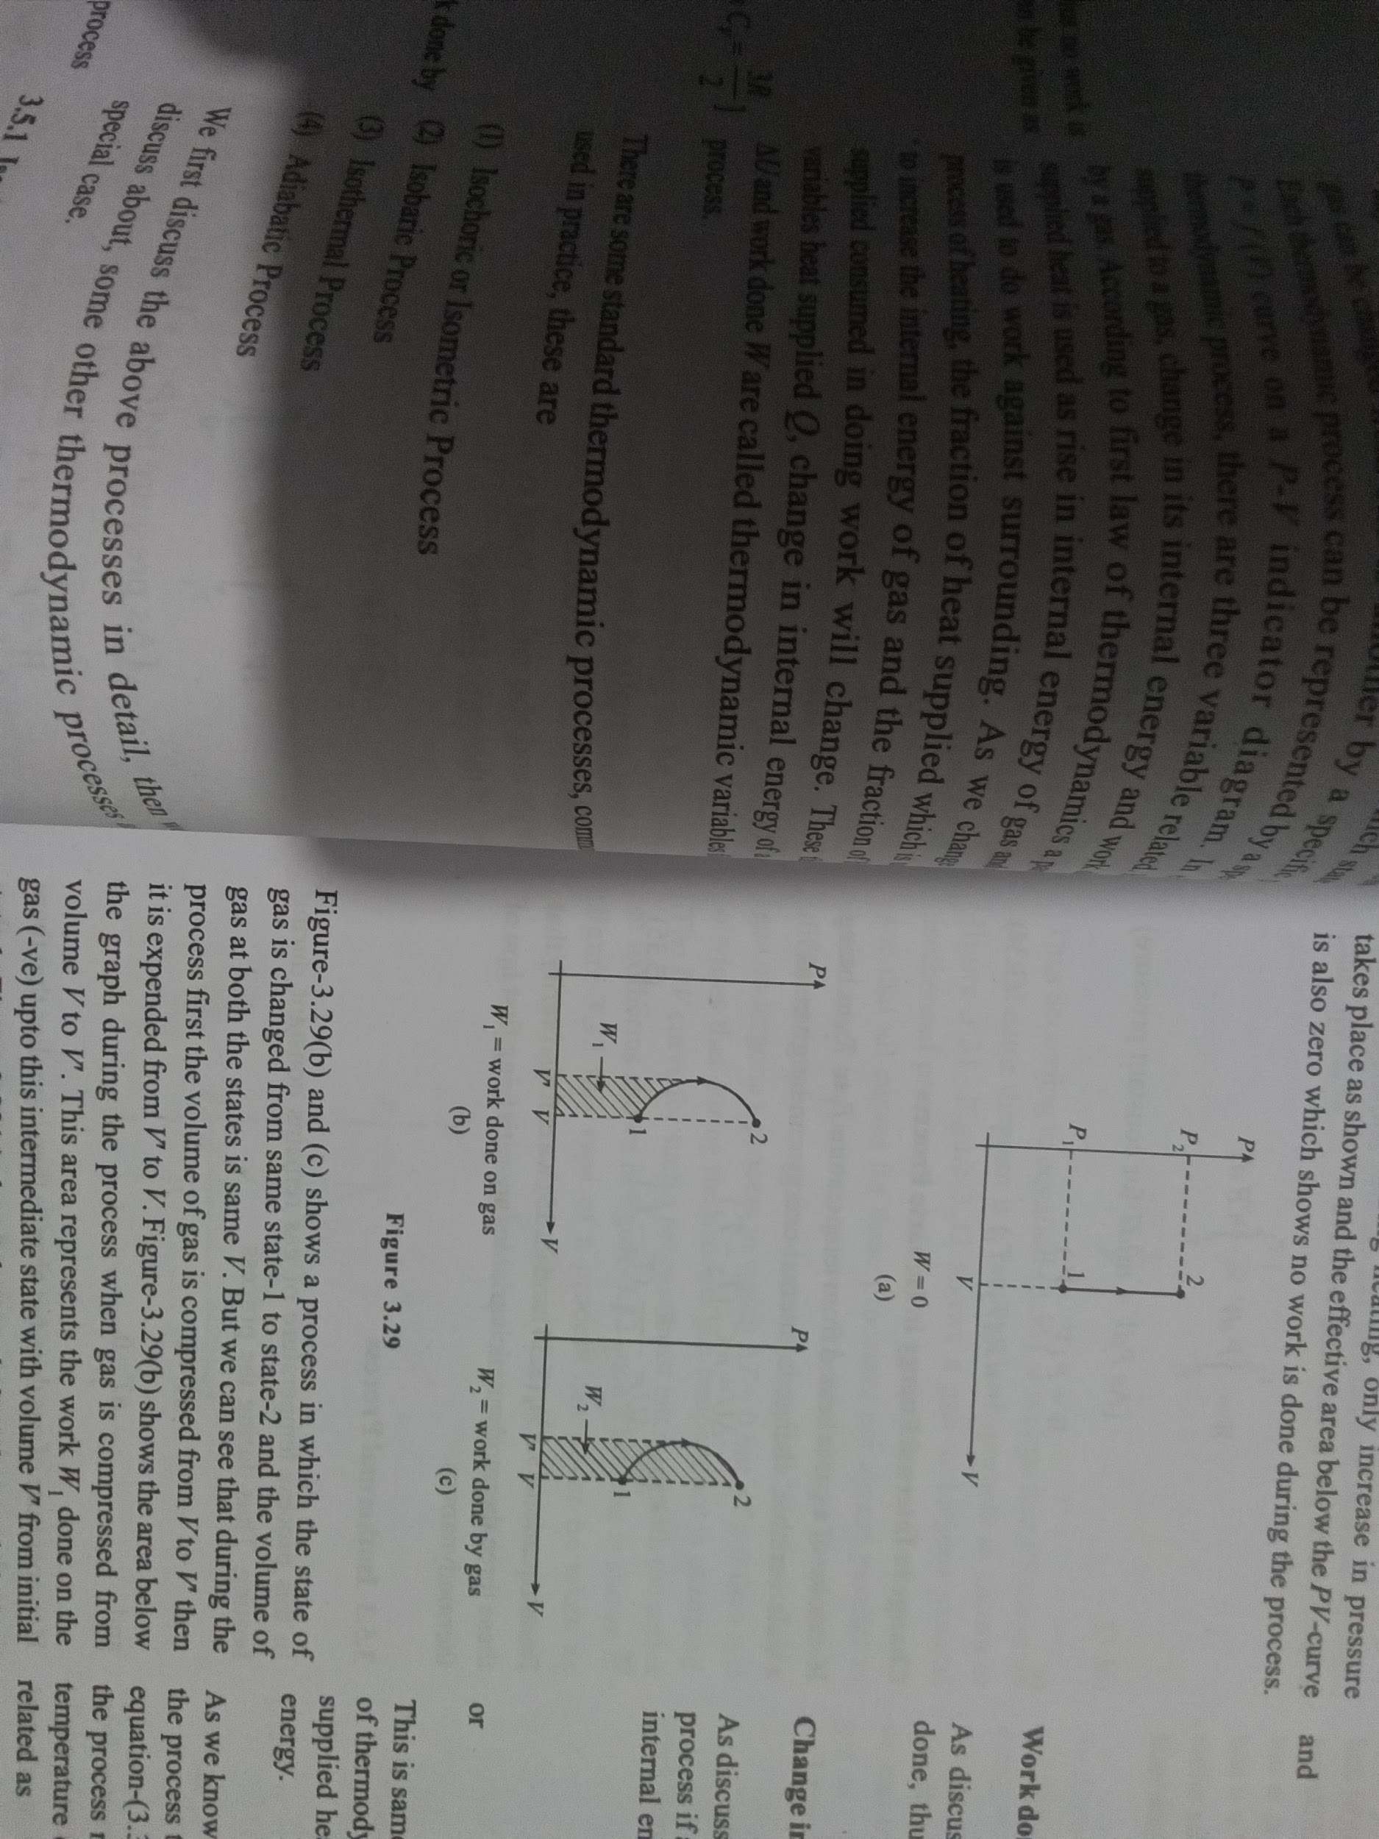

Figure-3.29(b) and (c) shows a process in which the state of gas is changed from same state-1 to state-2 and the volume of gas at both the states is same V. But we can see that during the process first the volume of gas is compressed from V to " then it is expended from V' to V. Figure-3.29(b) shows the area below the graph during the process when gas is compressed from volume V to V. This area represents the work W_{1} done on the gas (-ve) upto this intermediate state with volume V" from initial state-1. Figure-3.29(c) shows the area below the graph during the process when gas is expanded from this intermediate state to the final state to restore the volume V of the gas. This area during expansion of gas represents the work W_{2} done by the gas from this intermediate state with volume V to the final state-2. It is clear that W_{2} > W_{1} hence the total work in this process is done by the gas and is given as W gas =W 2 -W 1 Although in the process Delta*V = 0 but the process is not isochoric.

Heat supplied in Isochoric Process

If n moles of a gas is heated from temperature T_{1} to T_{2} keeping its volume constant during heating, the total amount of heat supplied to the gas can be obtained by using molar heat capacity of gas at constant volume as

dQ = n*C_{V}*dT

Q = intdQ = int_T_{1} ^T_{2} nC_{V} dT

Q = n*C_{V}((T_{2} - T_{1}) = (nR)/(gamma - 1) (T_{2} - T_{1})

Work done in Isochoric Process

As discussed earlier, no change in volume implies no work done, thus ...(3.30)

W = 0

Change in Internal Energy in Isochoric Process

As discussed earlier, internal energy is a state variable so in all process if a gas is heated from temperature T_{1} to T_{2} change in internal energy is given by

DeltaU = f/2 nRDeltaT = nC_{V}DeltaT

DeltaU = (nR)/(gamma - 1) (T_{2} - T_{1})

This is same as equation of heat supplied because according to first law of thermodynamics if no work is done in a process, whole of supplied heat to a gas will appear as increase in its internal energy.

As we know internal energy of a gas is a state function, in all the process the change in internal energy is always given by - equation-(3.31). As in isochoric process, volume of gas during the process remains constant from gas law the pressure and temperature of gas between its initial and final state can be related as

P_{1}/T_{1} = P_{2}/T_{2}

Isobaric Process

In this process during change of state of a gas, its pressure remains constant. Thus

dP = 0

DeltaP = 0

Again some process can be there in which Delta*P = 0 but d P ne0 Such process can not be taken as isobaric process. We can discuss these by their PV- diagrams shown in figure-3.30. Figure-3.30(a) represents an isobaric process in which a gas is taken from state-1 to state-2 and during the process only volume of gas is being changed from V_{1} to V_{2} pressure remains constant at P. Thus the area below the curve P (V_{2} - V_{1}) gives the work done in the process. But in figure-3.30(b) and (c), the gas is taken from same state-1 to state-2 by different paths in which during the process, the pressure of gas is not constant thus in these processes, even Delta*P = 0 but d P ne0 and due to this work done or area below these PV curves are either less or more than the case when the pressure remains constant i.e. in an isobaric process.

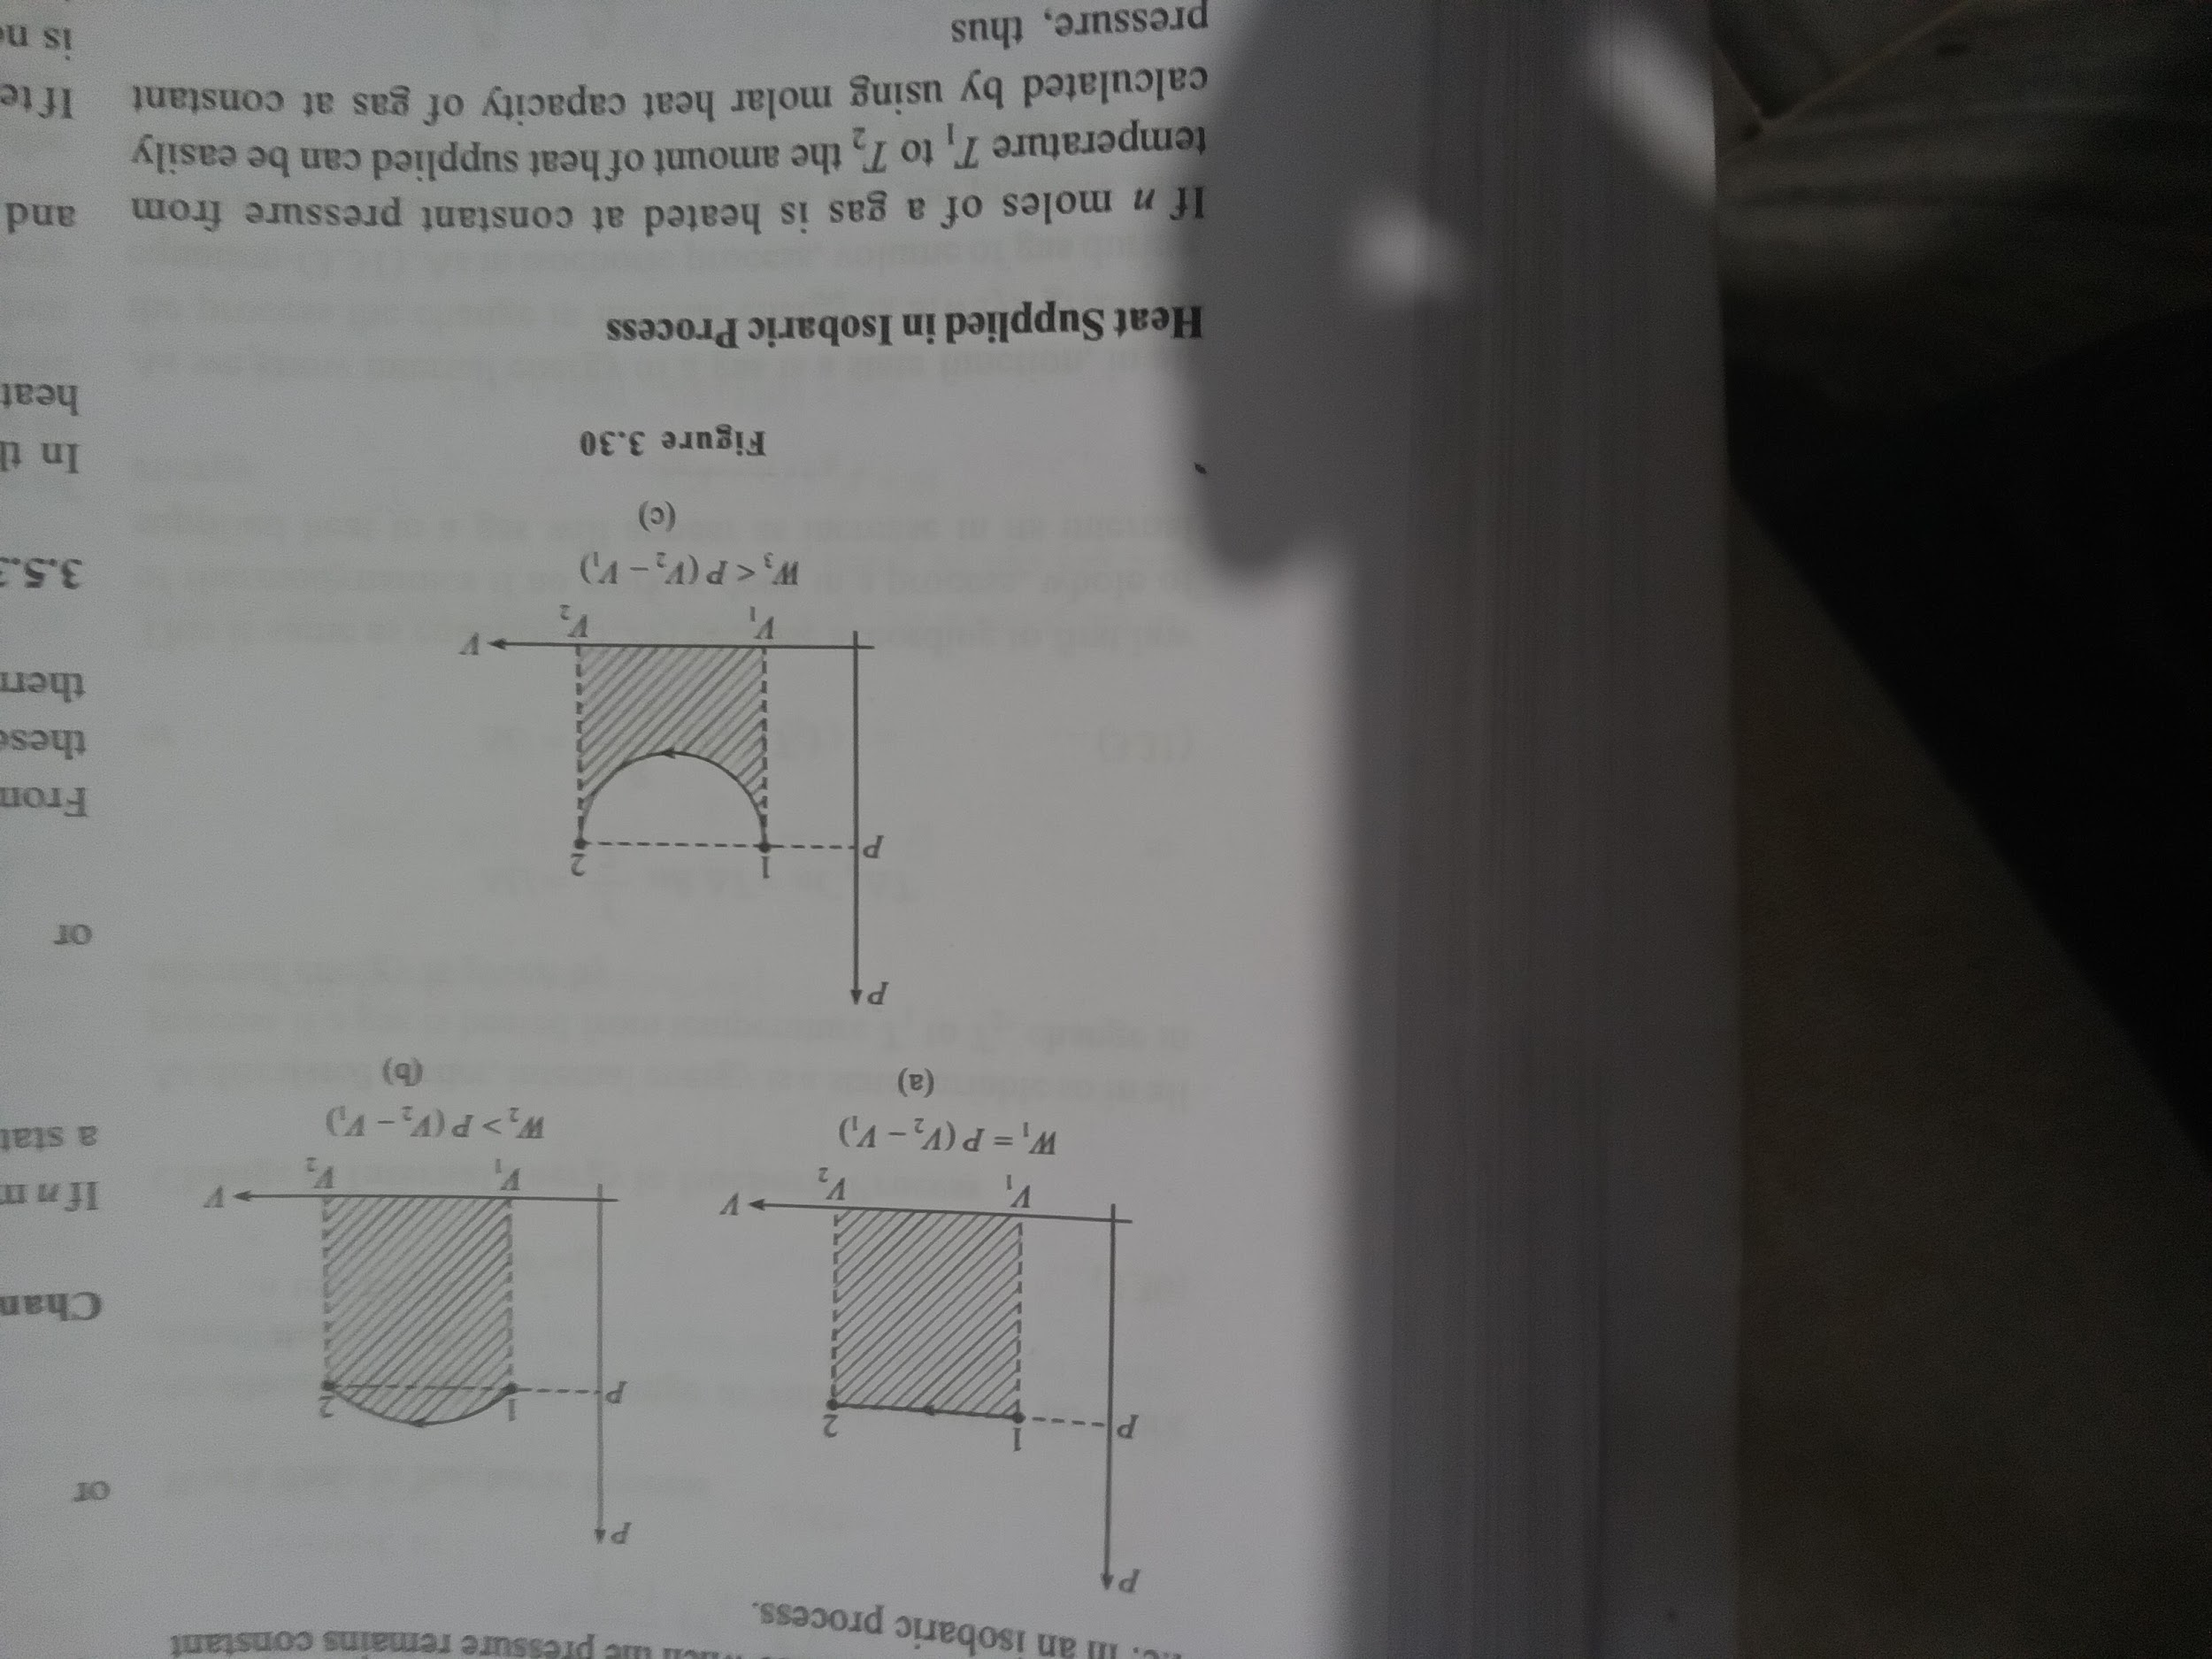

Heat Supplied in Isobaric Process

If n moles of a gas is heated at constant pressure from temperature T_{1} to T_{2} the amount of heat supplied can be easily calculated by using molar heat capacity of gas at constant pressure, thus

dQ = nC_{P}dT

Q = int dQ = int_T_{1}^T_{2} nC_{P} dT

Q = nC_{P}(T_{2} - T_{1})

Q = (ngammaR)/(gamma - 1) (T_{2} - T_{1})

Work Done by gas in Isobaric Process

At the beginning of chapter we've discussed that when a gas is heated from volume V_{1} to V_{2} work done can be calculated as

W = int dW = int_V_{1}^V_{2} PdV

As pressure of gas is constant, we have

W = int_V_{1}^V_{2} PdV = int_T_{1}^T_{2}nRdT [As PdV = nRdT for constant pressure]

W = P(V_{2} - V_{1}) = nR(T_{2} - T_{1})

Change in Internal Energy in Isobaric Process

If'n moles of a gas is heated from temperature T_{1} to T_{2} as being a state variable, change in internal energy can be given as

DeltaU = nC_{V}(T_{2} - T_{1})

DeltaU = (nR)/(gamma - 1) (T_{2} - T_{1})

Isothermal Process

In this process temperature of gas remains constant during heating. Thus during the process

dT = 0

DeltaT = 0

If temperature of gas does not change then it implies that there is no change in internal energy of gas during the process thus in an isothermal process, we also have

dU = 0

DeltaU = 0

As no change is there in internal energy of a gas, then according to first law of thermodynamics we can say that the total amount of heat supplied to a gas is used in doing work against surrounding i.e. in expending the gas.

Indicator diagrams for an Isothermal Process

To plot an indicator diagram we must require a process equation which can be given by gas law, in case of an isothermal process. According to gas law

PV = nRT

As in isothermal process gas temperature remains constant, thus, we have

P propto 1/V

P = k/V

Thus according to equation-(3.35), it is clear that PV curve on an indicator diagram is a rectangular hyperbola as shown in figure-3.31. Figure-3.32 shows a gas undergoes several isothermal processes at different temperatures. Here we can see that all curves for these processes are almost parallel to each other and no two curves can intersect as these are at different temperatures these curves are called "Isotherms". If a gas undergone a process in which triangle T = 0 but d T ne0 then it is obvious that during the process gas temperature is changing. The PV curve for such a process must intersect with the series of isotherms shown in figure-3.32 such a process is shown in figure-3.33 this type of a process can never be taken as isothermal process, however in this process also internal energy of gas in its initial and final state are same.

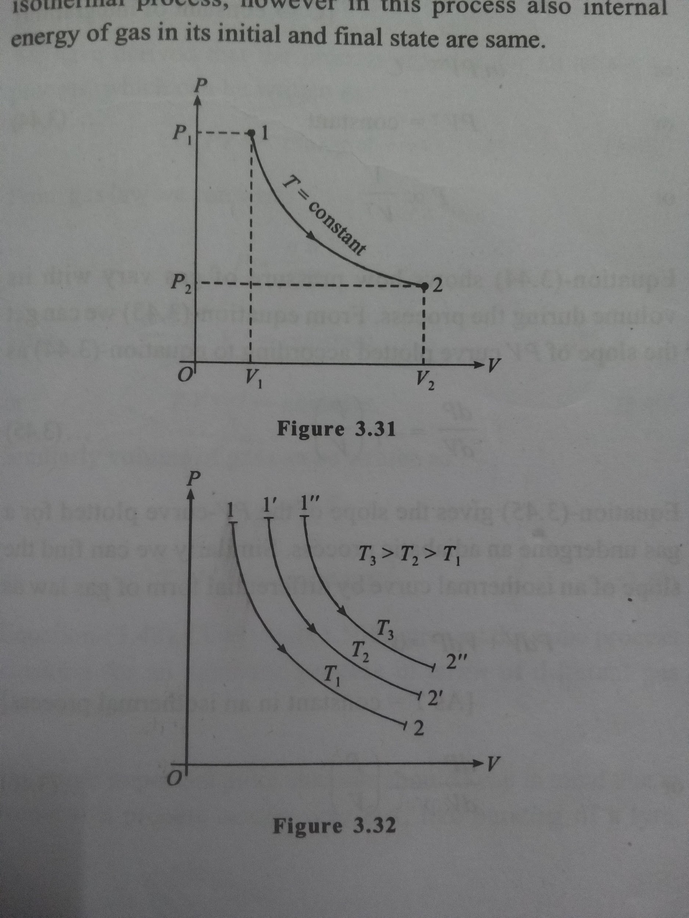

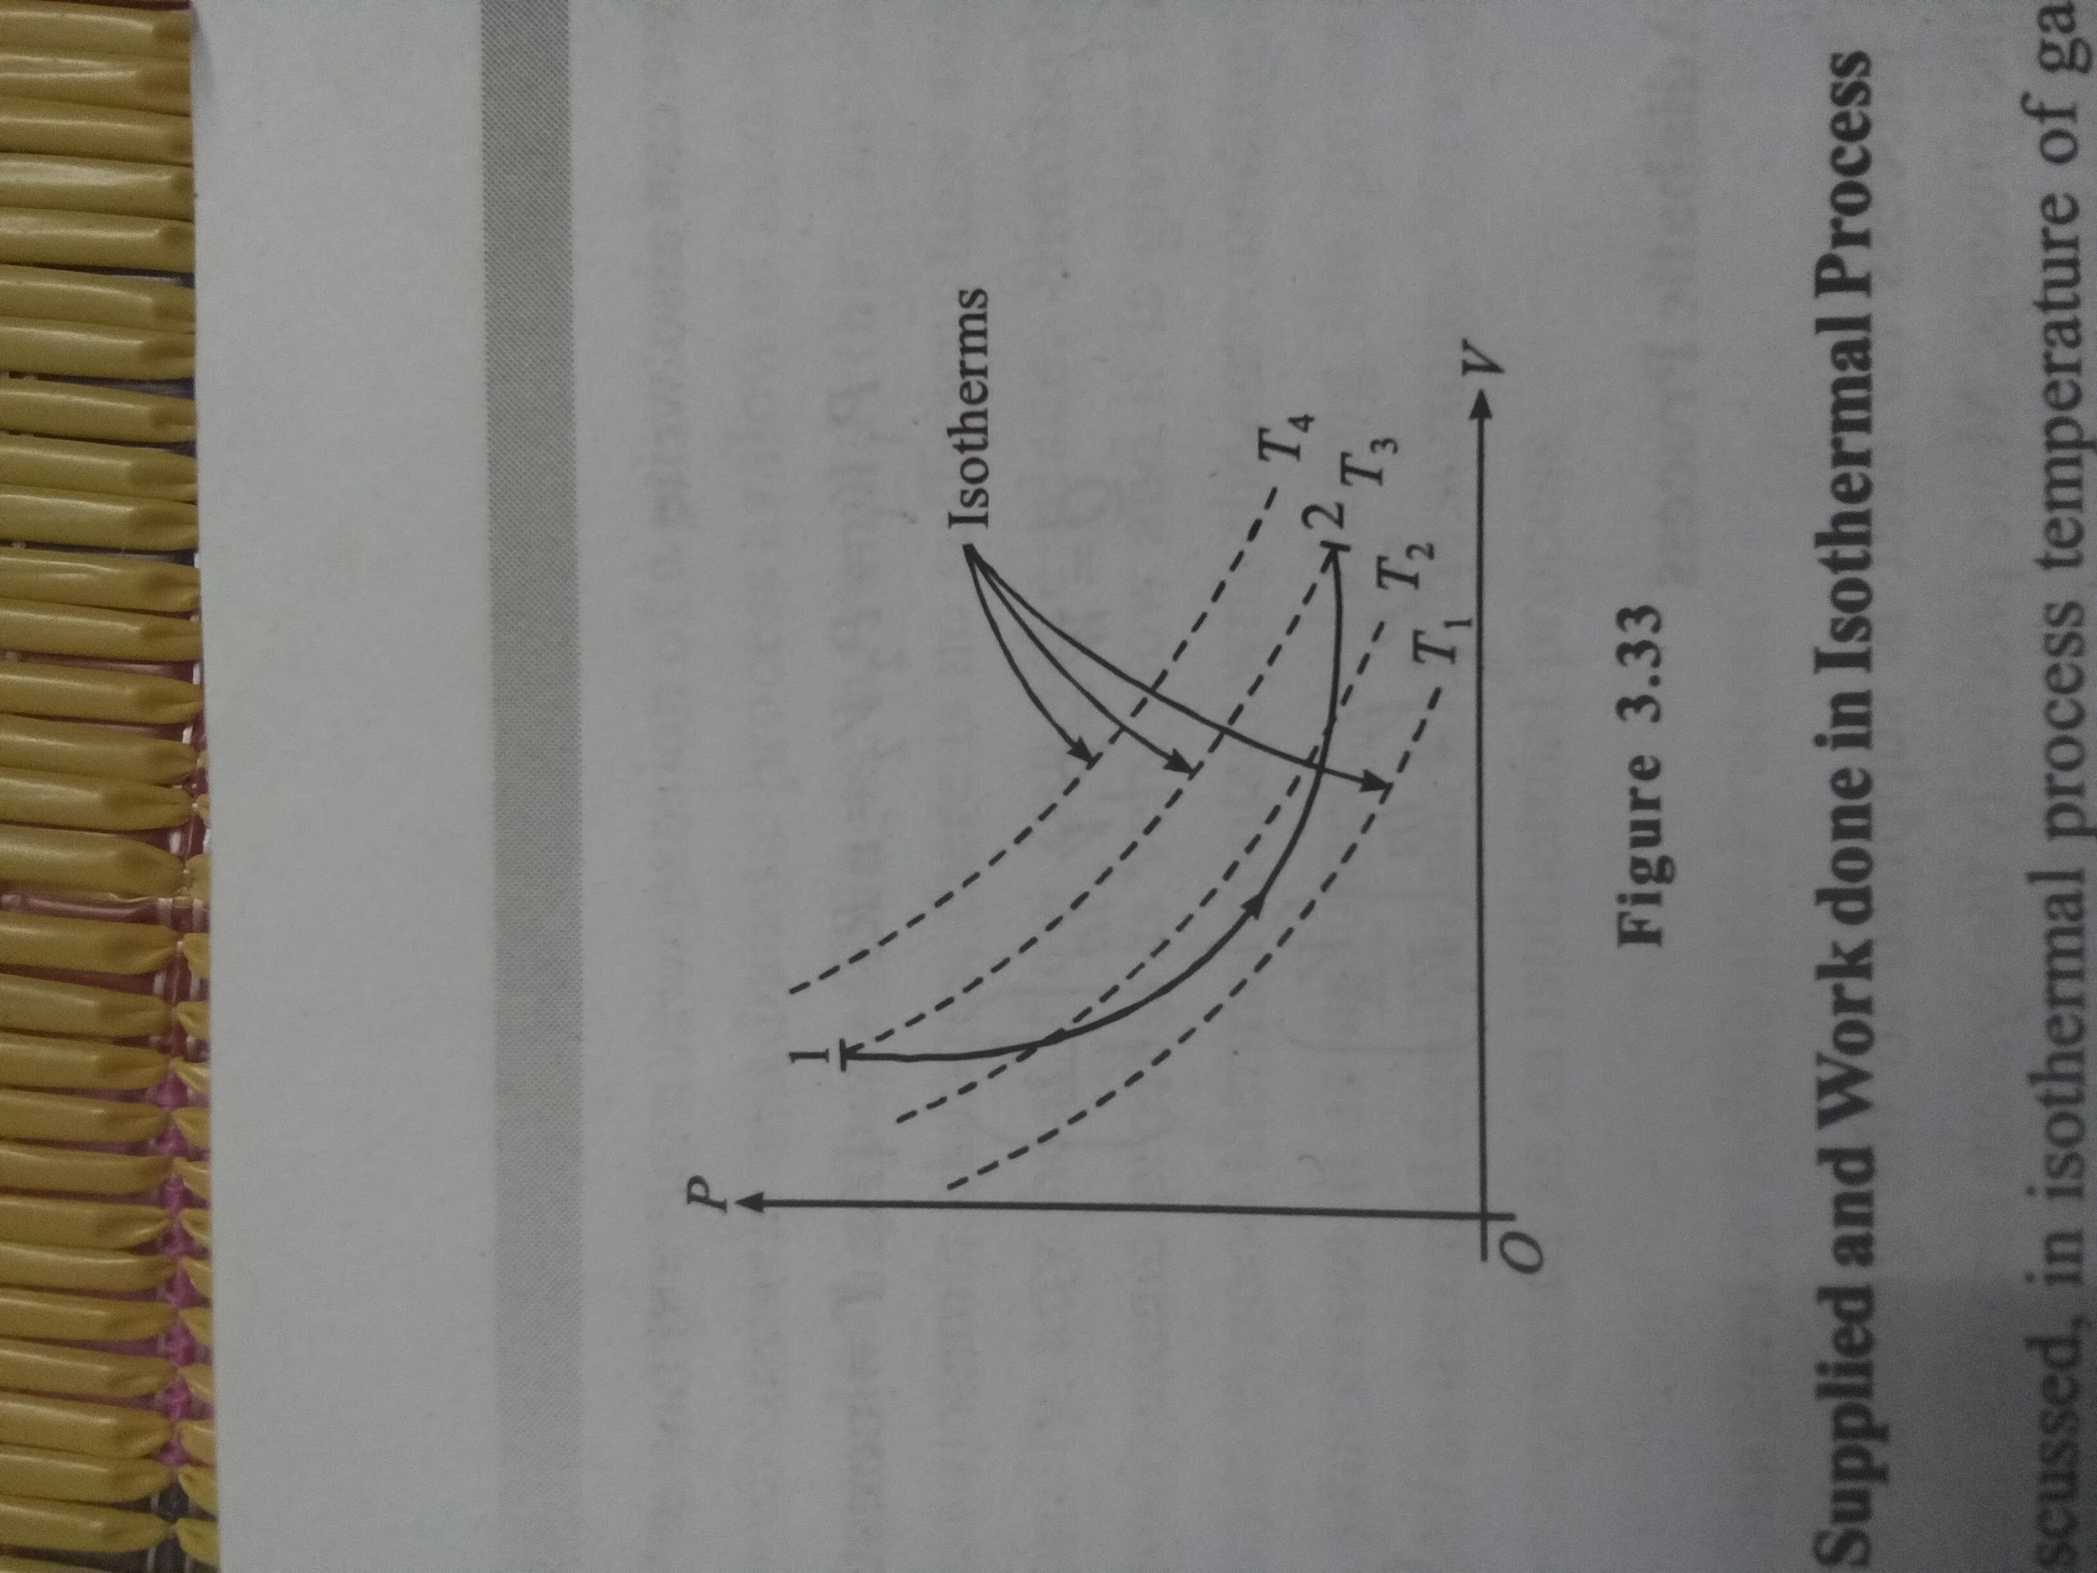

Heat Supplied and Work done in Isothermal Process

As discussed, in isothermal process temperature of gas does not change thus the total heat supplied to the gas is used in doing work against surrounding. If during the process volume of gas increases from V_{1} to V_{2} then pressure also very simultaneously with it and as temperature remains constant we can use Boyle's law to relate pressure and volume of the gas as

P_{1}V_{1} = P_{2}V_{2}

[If P_{1} and P_{2} are the initial and final pressures of gas]

Work done by the gas can be calculated as

W = int_V_{1}^V_{2} PdV

W = int_V_{1}^V_{2} (nRT)/V dV

[As P = (nRT)/V at every intermediate state of gas during heating]

W = nRT ln(V_{2}/V_{1}) = nRT ln(P_{1}/P_{2})

As change in internal energy in the process is zero, we have heat supplied

Q = W = nRT ln(V_{2}/V_{1})

= nRT ln(P_{1}/P_{2})

Here we can also write

P_{1}V_{1} = P_{2}V_{2} = nRT [As T = constant]

Q = W = P_{1}V_{1} ln(V_{2}/V_{1})

= P_{2}V_{2} ln(V_{2}/V_{1})

3.5.4 Adiabatic Process

In this process no heat is supplied to the gaseous system during the process. More precisely the system remains thermally insulated so that no heat can be given to it or can be taken out from it during the process. Thus here Delta*Q = 0 as well as dQ = 0 If no heat is supplied to a gas then according to first law of thermodynamics, during the process we have

dW + dU = 0

dW = - dU

Equation shows that if a gas expands in such a process or work is done by the gas, then by the same amount internal energy of gas decreases. It is obvious that if gas is doing work against surrounding then the amount of energy required in this work is extracted from the internal energy of gas as there is no external heat supply. This is called adiabatic expansion and in adiabatic expansion always the gas is cooled. Similarly when some external work is done on the gas, by the same amount its internal energy must increase as there is no rejection of heat in adiabatic process. Thus in adiabatic compression always gas temperature increases.

Indicator Diagram for an adiabatic process

To plot an indicator diagram we must have the relation in pressure and volume of a gas undergoing the process at one of its intermediate state during the process or the process equation for the process. In previous three standard thermodynamic processes, the process equations are directly given by the gas laws. Now we first discuss how to obtain the process equation in a general thermodynamic process.

How to derive the process equation for a thermodynamic process

In a general thermodynamic process to derive its process equation, we generally try to develop a relation in heat, work and change in internal energy for the process and then solve this relation with differential form of gas law to obtain the desired relation in any two of the thermodynamic parameters

of a gas pressure, volume and its temperature. For example first we derive the process equation for an adiabatic process,

For adiabatic process the differential form of first law of thermodynamics can be written as

dW=-dU

PdV= - nC_{V}dT

PdV = -(nR) /(gamma-1) dT

Equation is the differential form of first law of thermodynamics in terms of gas parameters pressure, volume and temperature.

Differential form of gas law can be written as

PdV+VdP= nRdT

Now , we get

PdV+VdP=(1-gamma) PdV

VdP=-gammaPdV ---------------------(1)

int (dP)/P = - gamma * int (dV)/V

ln(P) = - gamma ln(V) + C [C→ constant of integration]

ln(PV^gamma) = C

PV^gamma = constant

P propto 1/(V ^ gamma)

this Equation shows how pressure of gas vary with its - volume during the process. From equation-(1) we can get the slope of PV curve plotted according to above equation as

(dP)/(dV) = - gamma (P/V)

Equation above gives the slope of the PV-curve plotted for a gas undergone an adiabatic process. Similarly we can find the slope of an isothermal curve by differential form of gas law as

PdV+VdP=0 [As T = constant in an isothermal process]

(dP)/(dV) = - ( P/ V )

We can see that in magnitude slope of an adiabatic curve is y times more then the slope of an isothermal curve as

abs((dP)/(dV))_{adiabatic process} = gamma abs((dP)/(dV))_{isothermal process}

From above equation we can state qualitatively that an adiabatic curve is always steeper then an isothermal curve. If we note the values of y for a gas then it is maximum for a monoatomic gas. If we compare the isothermal and adiabatic curves for different types of gases starting with same initial state of a gas, we can see that the curve of a monoatomic gas in adiabatic process is the steepest and the curve for an isothermal process (independent from y) for a gas is having least slope. Figure- 3.34 shows the comparison. We can also note that the work done, the area below the P - V curve is minimum for the steepest graph.

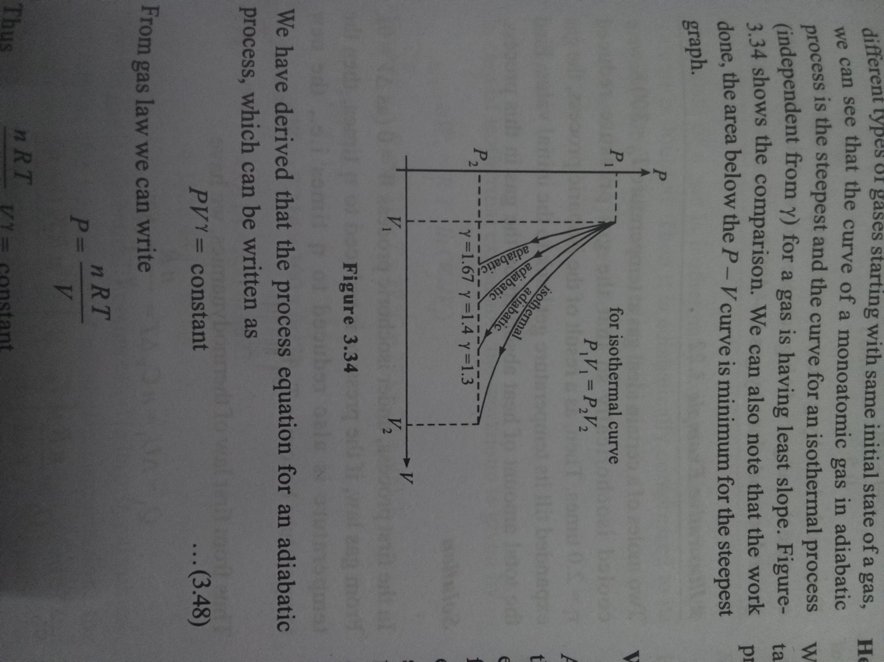

We have derived that the process equation for an adiabatic process, which can be written as PV^gamma = constant

From gas law we can write

P = (nRT)/V

(nRT)/VV^gamma = constant

TV^(gamma -1) = constant

Similarly volume of gas can be written as

V = (nRT)/P

T^gamma P^(1 – gamma) = constant

all these equations represent the same process equation for an adiabatic process in terms of different gas parameters.

One more important point students should keep in mind that in nature if a process occurs very fast, like bursting of a tyre, sudden compression or expansion of a gas, these are regarded as approximately an adiabatic process as flow of heat is a slow and gradual process. It is assumed that in sudden thermodynamic changes, there is no sufficient time available so hardly any heat flow can take place. Similarly if a thermodynamic process is very slow and it is given that the system is in good thermal contact with the surrounding then in such processes it is assumed that during the process gas remains in thermal equilibrium with the surrounding and thus it can be regarded as an isothermal process.

Heat Supplied in Adiabatic Process

We've discussed that in an adiabatic process no heat flow takes place between system and surrounding during the process (expansion or compression) thus

Q = 0

Work done and change in internal energy in adiabatic process

As already discussed, according to first law of thermodynamics the amount of work done by gas in an adiabatic process is equal to the negative of change in internal energy between final and initial state of the process. We know that internal energy is a state function thus does not depend as to how the state of a gas is changed. If gas temperatures are T_{1} and T_{2} before and after the process or in its initial and final states then the change (increase) in internal energy can be given as

Delta*U = integrate 1 dU = integrate (nR)/(gamma - 1) dT from T_{1} to T_{2}

= (nR)/(gamma - 1) * (T_{2} - T_{1}) Thus is adiabatic process work done by the gas can be written as W = - Delta * U = - (nR)/(gamma - 1) * (T_{2} - T_{1}) W = ((P_{1}*V_{1} - P_{2}*V_{2})/(gamma - 1)) ог ...(3.51) [As P_{1}*V_{1} = nR*T_{1} and P_{2}*V_{2} = nR*T_{2} ]

= These four process we've discussed are the most common processes realized in practice. But initially we've discussed that there can be infinite ways of heating a gas are there thus there is no limitation on number of thermodynamic processes for a gas. Now we first take few examples to understand the above discussed processes in details then we will discuss a

general thermodynamic process named polytropic process, there after we'll see that the above four processes are also the special cases of polytropic process.

Free Expansion of a Gas

When heat is added to a thermodynamics system, it undergoes a change of state which depends on the path from the initial state to final state. We take an example of it. Figure-3.35 shows an ideal gas contained in a cylinder with a piston having an initial volume of 5 litre at temperature 300 K. We want to increase its volume from 5 litre to 8 litre. We put this cylinder on to a heater at same temperature 300 K Heater supplies heat to the gas and the gas expands slowly and after expending in the slow and isobaric manner, the gas reaches its final volume of 8 litre. In this process gas absorbs a definite amount of heat.

Polytropic Process

A polytropic process is one in which the molar specific heat of a gas during the process (heating) remains constant or does not change with the gas parameters pressure, volume or temperature. If for a polytropic process molar specific heat is taken C then according to first law of thermodynamics, we have

dQ = dU + dW nC * dT = (nR * dT)/(gamma - 1) + PdV C = R/(gamma - 1) + (PdV)/(ndT) or or ...(3.63) From gas law

P * dV + V * dP = nRdT

...(3.64)

From (3.63) and (3.64) C= R gamma-1 + RPdV P * dV + VdP

Pdv (c--)--(-) Vap R R -R = (dV)/V * ((m - R)/m) =- dP P R ...(3.64) .(3.65) or or

[Where m = C-

Integrating the expression, we get

((m - R)/m) * integrate 1/V dV = - integrate 1/P dP

γ-1

= constant]

((m - R)/m) * ln(V) = - ln(P) + C_{1} [ C_{1} = integration constant]

or ln(P * V ^ ((m - R)/m)) = C_{1} PV" constant n = (m - R)/m or ...(3.66) is another constant which is called Where polytropic constant whose value depends on y of gas, gas constant R and the molar specific heat C of the process which is taken a constant equation-(3.66) shows that if the process equation of a process is represented in the form of P * V ^ n = constant then it can be regarded as a polytropic process and the molar specific heat for a polytropic process can be defined by using first law of thermodynamics by equation- (3.65) as C = R/(gamma - 1) + (RP * dV)/(P * dV + VdP) P * V ^ n = const we have dPV+nPV-1 dV=0 dP = - (nP)/V * dV

From (3.67) and (3.68) we have C = R/(gamma - 1) + (RP * dV)/(P * dV + V(- (nP)/V * dV)) C = R/(gamma - 1) + R/(1 - n) C = (R(gamma - n))/((gamma - 1)(1 - n)) or ...(3.69) (3.70) Equation-(3.69) and (3.70) gives the molar heat capacity for a general polytropic process. If the polytropic constant n is known we can directly find the molar heat capacity C for the respective process using equation-(3.69) or (3.70) which directly gives the total amount of heat supplied to a gas as if n moles of gas are heated from a temperature T_{1} to T_{2} then the total heat supplied for the purpose is given as Q= int T 1 ^ T 2 nCdT Q = nC(T_{2} - T_{1}) or ...(3.71) As internal energy change for any process can be given as Delta*U = n*C_{V}(T_{2} - T_{1})

Thus work done in a polytropic process can be written from equation-(3.72) and (3.73) as W = Q - Delta*U W = n(C - C_{v})(T_{2} - T_{1}) ...(3.73)

3.7.1 Standard Processes as a Special Case of Polytropic Process

As discussed earlier the four standard processes are the special cases of general polytropic processes. Now we discuss these processes again in terms of polytropic process

(i) Isochoric Process

We know in an isochoric process, the process equation for the process is

V= constant The general equation for polytropic process PV" = constant, approaches this result when n -> ∞ and in this case the molar specific heat of the process is given by equation-(3.69) as C = R/(gamma - 1) + R/(1 - n) C = R/(gamma - 1) = C_{v} As n -> ∞ Which is in favour of the process

(ii) Isobaric process

Here in isobaric process the process equation is given as P= constant From the general equation of polytropic process P * V ^ n = constant, above equation is obtained by substituting polytropic constant n = 0 Thus molar specific heat of this process can be given by equation-(3.69) as C = R/(gamma - 1) + R/(1 - n) C = R/(gamma - 1) + R = C_{v} + R = C_{P} or Hence it is also same as that used for constant pressure heating.

(iii) Isothermal process

Here during the process temperature of system remains constant thus the process equation is given as

PV= constant

From general equation of polytropic process here we can see that for an isothermal process the polytropic constant n = 1

Thus if we find molar specific heat for isothermal process from equation-(3.65), we get

C = R/(gamma - 1) + R/(1 - n) C longrightarrow ∞

or

This is also obvious that in isothermal process temperature of gas never changes and molar heat capacity is the amount of heat required to change the temperature for one mole of gas by one degree. So if we continuously supply heat to a gas infinitely then also its temperature will not change then it is undergoing an isothermal process.

(iv) Adiabatic process

In previous section we've derived the process equation of an adiabatic process, given as PVY constant Thus for an adiabatic process, the polytropic constant is equal to the adiabatic exponent of the gas, n = gamma Now from equation- (3.69) we can see that the molar heat capacity for a gas in adiabatic process is

C = R/(gamma - 1) + R/(1 - n)

C = 0

Again here it is obvious that in an adiabatic expansion or compression, temperature of gas changes without any supply of heat. Thus in this process no heat is required to raise the temperature of gas.

3.7.2 Indicator Diagram For a Polytropic Process

ог

The general process equation is PV = constant P propto 1/(V ^ n) We know if n = 1 , it becomes an isothermal process, PV-curve of which is a rectangular hyperbola and the slope of the curve is given as d/dV (P) = - n * (P/V) |(dP)/(dV)| Polytroplc =n| dP dV | Isolhemal or

.(3.74)

Thus for a process if polytropic constant n is more then unity then this curve will be steeper then isothermal curve and if

n < 1 then its slope will be less then isothermal curve. Figure-3.44 shows various PV-curves for different value of n for some standard and general